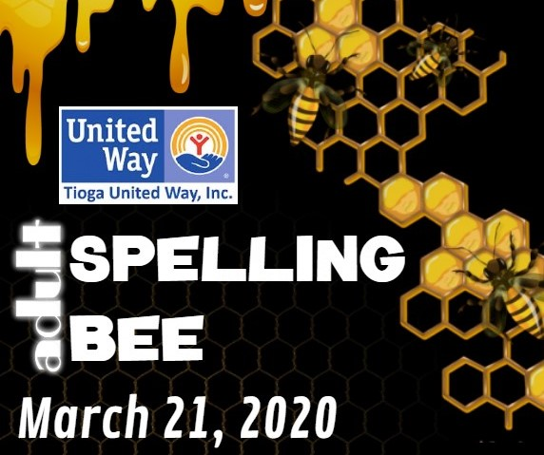
TEAM #
_________
Team Registration Form
To participate in the 5rd Annual Tioga United Way Adult Spelling Bee, please complete this form and return it by Friday, February 21, 2020. The entry fee per team is $100 (a team consists of 2-6 people & all participants must be 21 years of age or older). Please make checks payable to Tioga United Way and mail them to 24 State Route 96, Owego, NY 13827, or call 607-687-4028 to pay with a Credit Card, or pay online with a Credit Card. All proceeds go to the 31 Partner Agencies of the Tioga United Way. Thank you
Team Name___________________________________________________
Team Captain Name _____________________________________________
Team Captain Phone _____________________________________________
Team Captain Email ______________________________________________
Team Members
Name ________________________________ Email _________________________________________
Name ________________________________ Email _________________________________________
Name ________________________________ Email _________________________________________
Name ________________________________ Email _________________________________________
Name ________________________________ Email _________________________________________
Name ________________________________ Email _________________________________________
Team Sponsor
(If a business or individual is sponsoring your team, please provide their name and email so we can include them on all publications and social media outlets)
Name _____________________________ Email _________________________________
*Please send your Team Sponsor’s logo to tiogaunitedway@stny.rr.com
For Office Use Only: Date: _______________
Cash Receipt __________ Check # ___________ CC # ___________________________________________
Card Holder _____________________________________________ EXP ______________ CCV ________
Phone # ___________________________ E-mail ____________________________________________
Address _____________________________________________________________________________________

